GLOBAL ACADEMY OF TECHNOLOGY

Autonomous Institute Affiliated to VTU Ideal Homes Township, Rajarajeshwari nagar, Bengaluru

# DEPARTMENT OF ARTIFICIAL INTELLIGENCE AND MACHINE LEARNING

SUBJECT: DATABASE MANAGEMENT SYSTEMS (21AML43) TOPIC: PROJECT REPORT

# MEDICONNECTS: “ A DOCTOR RECOMMENDATION WEBSITE”



TEAM MEMBERS

KUSUMA 1GA21AI025

MANDHARA 1GA21AI028

PRIYANKA B 1GA21AI039

SANJANA 1GA21AI047

INTRODUCTION:

According to WHO data, heart disease is the leading cause of mortality globally, resulting in 17.9 million deaths annual The most risk factors for cardiovascular disease and stroke are unhealthy food, lack of physical activity, smoking, and alcohol drinking A heart attack occurs when the heart’s blood circulation is obstructed by arteries plaque build-up. A thrombus in an artery causes a stroke by impeding blood flow to the brain The symptoms are common to other illnesses and might be confused with indicators of ageing, making diagnosis difficult for practitioners.

Precision prediction and timely identification of cardiac disease are essential for improving patient survival rate. Because of the increased collection of medical data, practitioners now have a great opportunity to promote healthcare diagnosis. ML plays a vital role in many applications like text detection and recognition , early prediction, power quality disturbance detection, truck traffic classification , and agriculture ML has now become an essential tool in the healthcare sector to aid with patient diagnosis. The current methods for predicting and diagnosing cardiac disease are mostly dependent on practitioners’ evaluation of a patient’s medical history, signs, and physical assessment reports. Nowadays, information about patients with clinical reports is widely accessible in databases in the healthcare field, and it is rising rapidly day by day. In this article, the UCI ML repository’s Cleveland HD dataset was utilized for developing the prediction model to heart disease. The machine is trained for learning patterns based on the features that are already present in the dataset. Classification is an effective ML approach for prediction. When properly trained with adequate data, classification is an effective supervised ML method for identifying disease. The primary goal of this work is to employ contemporary ML techniques to construct the healthcare heart disease predictive model. The Cleveland HD dataset was subjected to SVM with radial basis function (RBF) kernel, Gaussian Naive Bayes, logistic regression, and random forest algorithm, and the best performing prediction model for early diagnosis of heart disease was found.

OBJECTIVES:

1. User Registration:

Users create accounts by providing basic information.

1. Search and Discovery:

Users input their location and medical specialty/condition. The website displays a list of relevant doctors based on the search criteria.

1. Doctor Profiles:

Each doctor's profile showcases details like name, photo, specialty, education, experience, and certifications.

1. Appointment Booking:

Users can view available appointment slots based on the doctor's schedule. They select a preferred time and date for their visit. The website confirms the

appointment and sends notifications.

1. Account Management:

Users can access their account dashboard to view upcoming appointments, appointment history, and saved doctors. They can also reschedule or cancel appointments if necessary.

1. Recommendations:

The website uses algorithms to suggest doctors based on user preferences, location, and medical history.

INTRODUCTION TO DBMS:

A Database Management System (DBMS) is a software system designed to manage and organize large volumes of data efficiently. It serves as an

intermediary between users and the underlying database, providing a structured and secure way to store, retrieve, update, and manage data. Here's a brief overview of DBMS:

* + Data Organization: DBMS allows for the structured organization of data into tables, rows, and columns, making it easier to store and retrieve information. This structured approach is commonly referred to as a

relational database.

* + Data Integrity: DBMS enforces data integrity by defining data

constraints, relationships, and rules, ensuring that the data remains accurate and consistent.

* + Data Security: It provides access control mechanisms to safeguard data from unauthorized access. Users and applications can have different

levels of access based on their privileges.

* + Data Retrieval: DBMS offers query languages (e.g., SQL - Structured Query Language) that enable users to retrieve specific data from the database using various criteria.
  + Data Maintenance: It simplifies data maintenance by allowing users to update, insert, or delete records with ease, ensuring data remains up to date.
  + Data Backup and Recovery: DBMS often includes tools for data backup and recovery, minimizing data loss in case of system failures or errors.

# There are various types of DBMS, including relational DBMS (RDBMS), NoSQL databases, columnar databases, and more, each tailored for specific use cases and data models. DBMS plays a crucial role in modern data-driven applications, from simple tasks like

managing a personal address book to complex enterprise systems handling vast amounts of information.

COMMON TOOLS USED FOR DBMS PROJECT:

Database Design Tools:

# ERD (Entity-Relationship Diagram) Software: Tools like

Lucidchart, draw.io, or Microsoft Visio are commonly used for designing the database schema.

# Database Modeling Tools: Tools like MySQL Workbench, Oracle SQL Developer Data Modeler, or DbSchema help create and visualize data models.

DBMS Software:

# Relational DBMS (RDBMS): Popular choices include MySQL, PostgreSQL, Oracle Database, Microsoft SQL Server, and

SQLite.

# NoSQL DBMS: For non-relational databases, tools like MongoDB, Cassandra, Couchbase, or Redis are used.

Testing and Quality Assurance Tools:

# Database Testing Tools: Tools like dbUnit, Apache JMeter, or proprietary tools for database testing.

* Automated Testing Frameworks: If you're building applications, tools like Selenium can be useful for end-to-end testing.

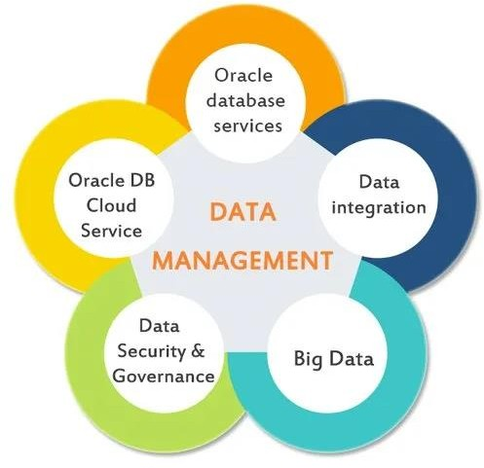

Softwares required for php and Mysql Project:

* + Web Server:
    - Apache: A popular open-source web server that can be used to host PHP applications.
  + PHP Development Environment:
    - PHP: Install the PHP scripting language on your development machine.
    - PHP Integrated Development Environment (IDE): Popular choices include PHPStorm, Visual Studio Code with PHP extensions, or

NetBeans. These IDEs provide code editing, debugging, and project management features.

* + Database Management System:
    - MySQL: A widely used open-source relational database

management system. You'll need MySQL to store and retrieve data for your PHP application.

* + Database Tools:
    - phpMyAdmin: A web-based tool for managing MySQL databases.
    - MySQL Workbench: A visual database design and management tool.
  + Version Control:
    - Git: To track changes in your project and collaborate with others. Hosting platforms like GitHub, GitLab, or Bitbucket can be used for repository hosting and collaboration.
    - Text Editor/Code Editor:A text or code editor like Visual Studio Code, Sublime Text, or Notepad++ for quick editing of code files.
  + Local Development Environment (Optional):
    - XAMPP, WAMP, MAMP: These packages bundle Apache, MySQL, and PHP together, making it easy to set up a local development environment on your machine.

SOFTWARE TOOLS:

Scikit-learn: Widely used for machine learning tasks, including classification algorithms for heart disease prediction.

TensorFlow and PyTorch: Deep learning frameworks that can be employed for complex modeling.

Statistical Software:

R and Python (NumPy, SciPy): Statistical analysis and data manipulation tools often used in healthcare analytics.

Data Processing Tools:

Pandas: For data manipulation and analysis, particularly useful in handling datasets related to heart health.

Visualization Tools:

Matplotlib and Seaborn: These Python libraries are useful for creating visualizations, aiding in the interpretation of data patterns.

Health Informatics Platforms:

WEKA (Waikato Environment for Knowledge Analysis): A suite of machine learning software applications, useful for data mining tasks in health informatics.

Electronic Health Record (EHR) Systems:

Epic, Cerner, etc.: EHR systems store patient data, providing a crucial source for training predictive models.

Clinical Decision Support Systems:

Dxplain, VisualDx: These systems integrate patient data and medical knowledge to aid clinicians in making informed decisions.

Web-Based Tools:

Django, Flask: Web frameworks that can be used to develop user interfaces for heart disease prediction tools.

Cloud Platforms:

AWS, Azure, Google Cloud: Cloud computing platforms that offer scalable resources for running complex models and storing large datasets.

Data Mining Tools:

Orange, KNIME: These tools provide a visual programming interface for data mining, facilitating the development of predictive models.

FRONTEND AND BACKEND CONNECTIONS:

* User Interface (UI): The frontend development involves creating the user interface where users interact with the application. HTML, CSS, and

JavaScript are commonly used for building the frontend.

* AJAX or Fetch: JavaScript allows you to make asynchronous requests to the backend using techniques like AJAX (Asynchronous JavaScript and XML) or the modern Fetch API. These requests are typically done using HTTP methods such as GET, POST, PUT, or DELETE.
* Frameworks and Libraries: Frontend frameworks and libraries like React, Angular, Vue.js, or jQuery can simplify the development of interactive user interfaces.
* Form Handling: Frontend forms collect user input and transmit it to the backend for processing. Data from forms is often sent in JSON or other structured formats.
* Server-Side Code: The backend is responsible for processing requests, interacting with databases, and performing business logic. Common backend programming languages include PHP, Python (with frameworks like Django or Flask), Ruby (with Ruby on Rails), Node.js, and Java (with Spring or JavaEE).
* Web Server: A web server like Apache, Nginx, or a server built into your backend framework handles incoming HTTP requests and routes them to the appropriate backend code.
* API Development: The backend typically exposes APIs (Application Programming Interfaces) that define how data can be requested and submitted to the server. These APIs are typically exposed as endpoints, often using RESTful principles or GraphQL.
* Database Connection: Backend code connects to a database management system (e.g., MySQL, PostgreSQL, MongoDB) to retrieve, store, and manipulate data.
* Security: Backend code should handle user authentication, authorization, and validation to ensure data security.
* API Calls: The frontend makes API requests to specific endpoints on the backend using HTTP methods. These requests include data that the backend needs to process.

Deployment:Host both the frontend and backend components on web servers or cloud platforms, making them accessible to users

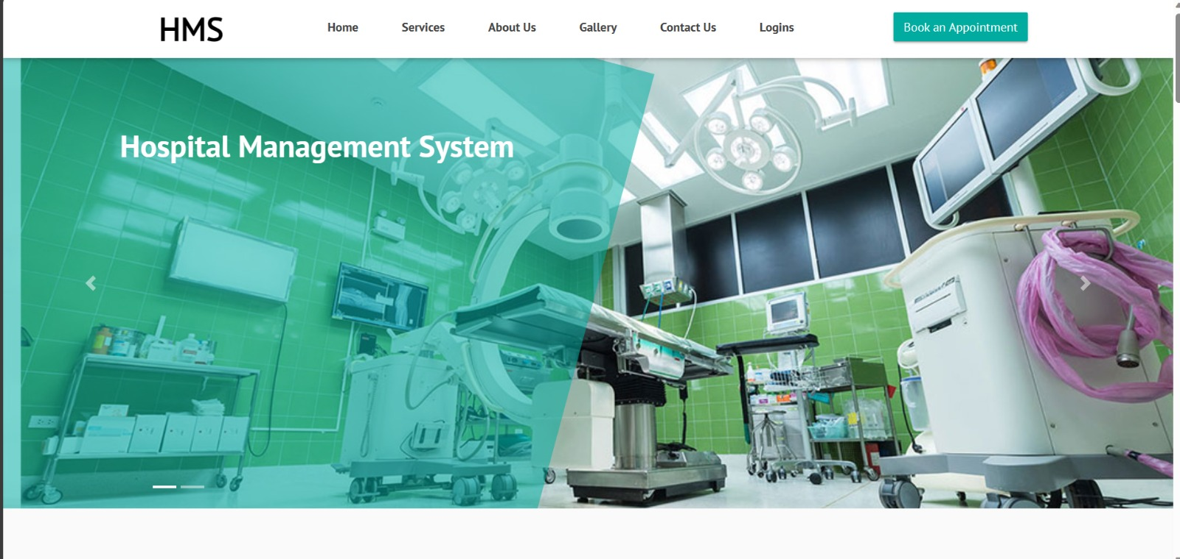

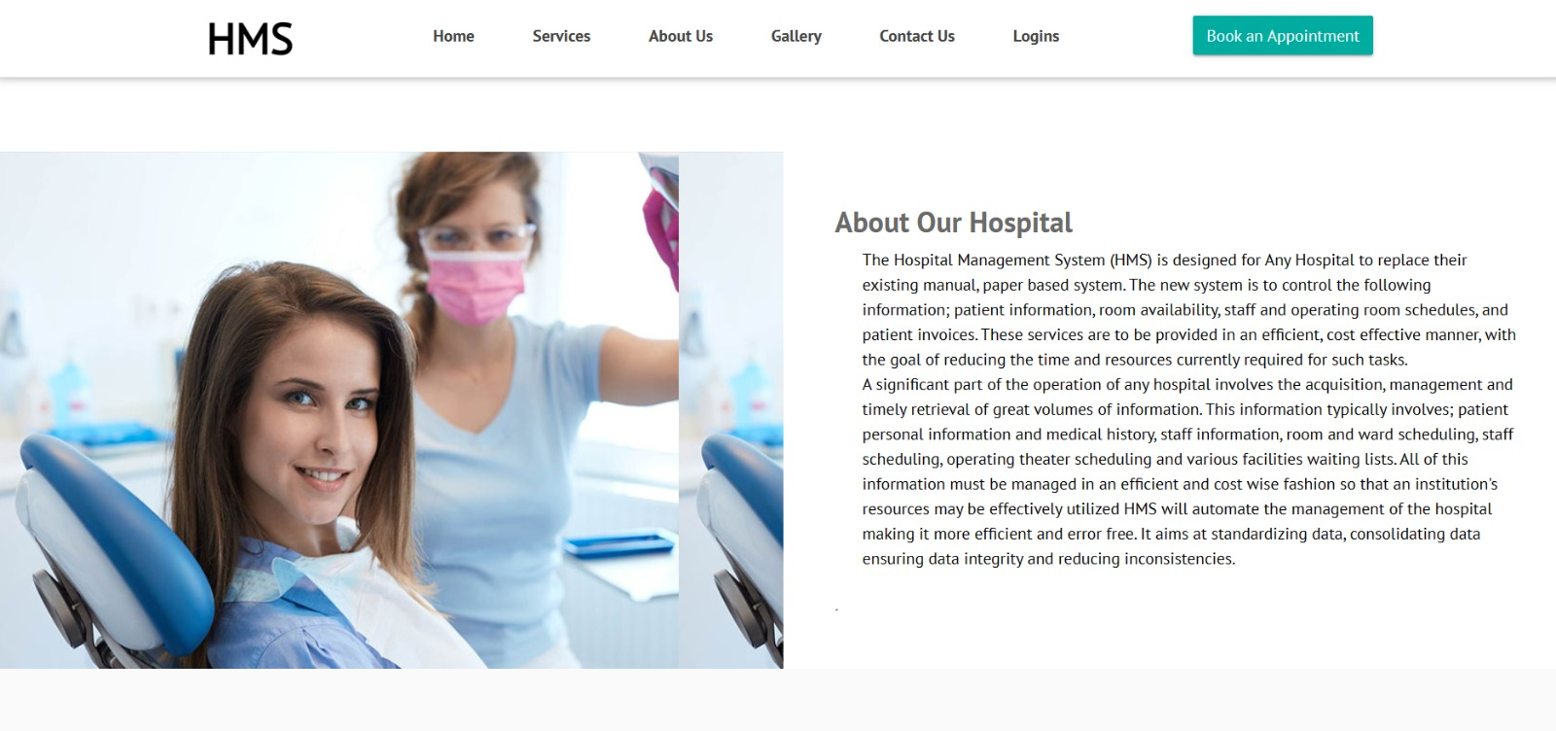

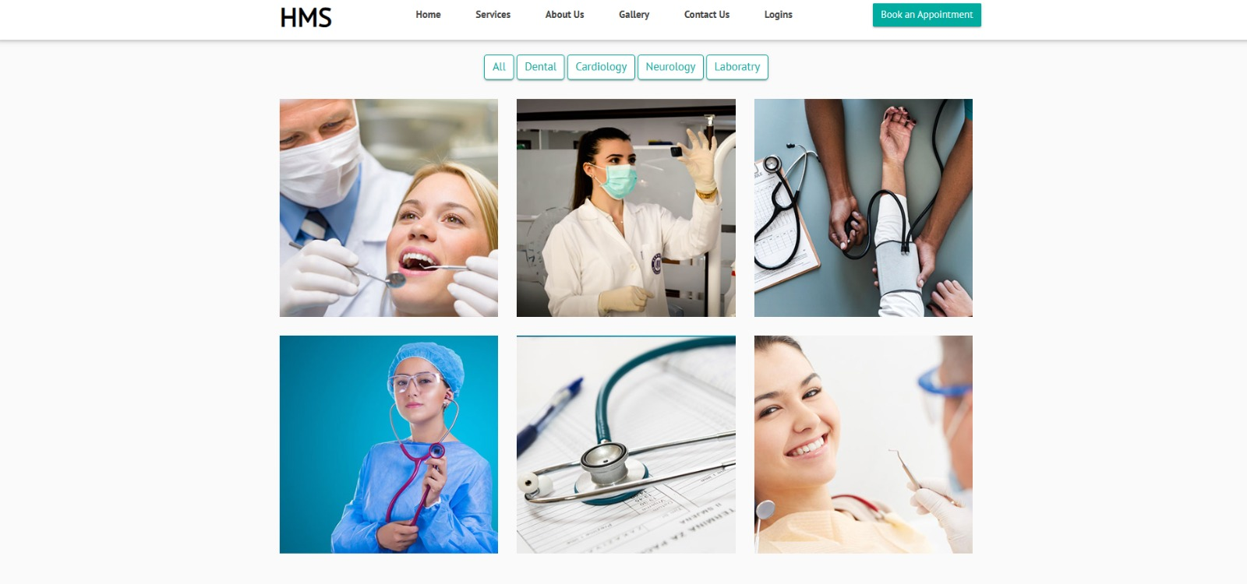

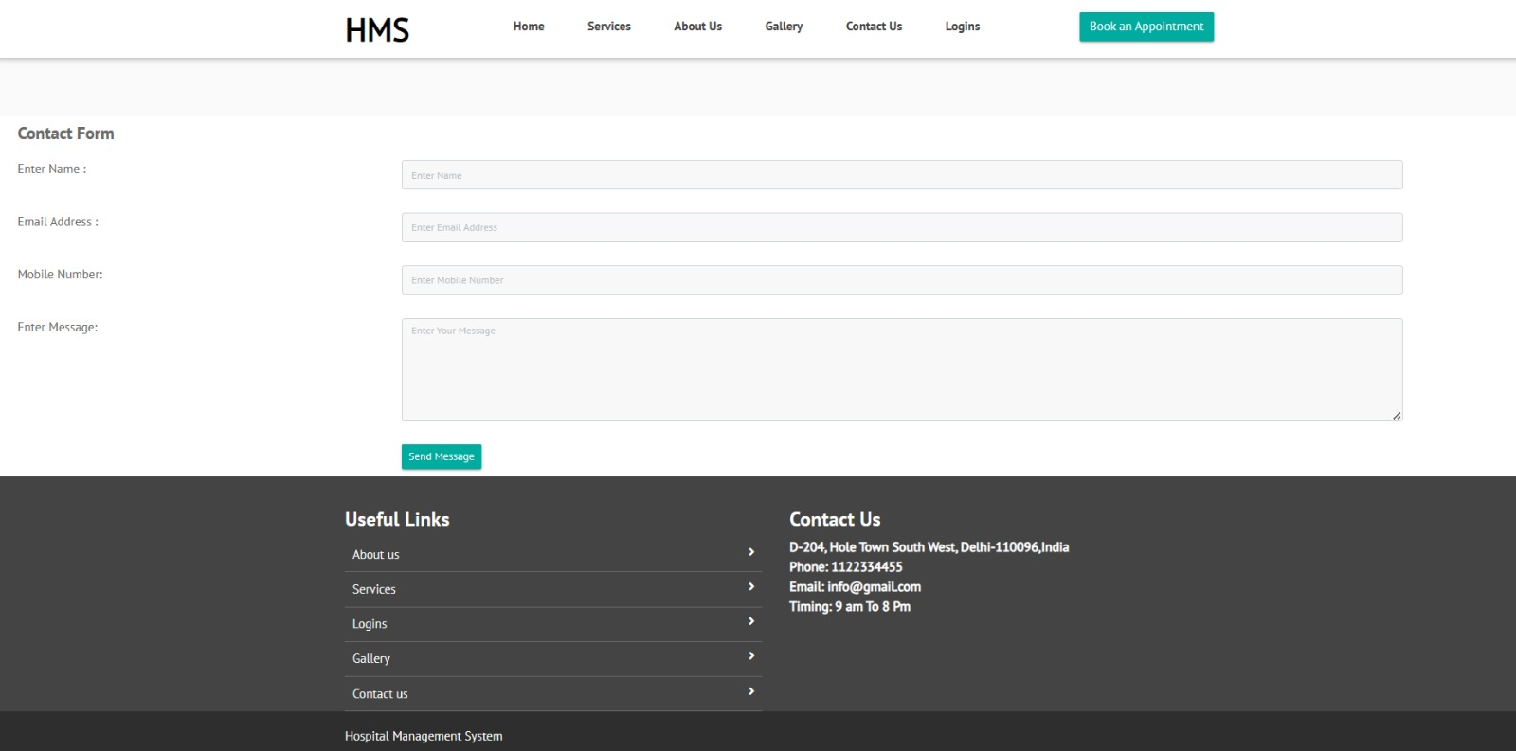

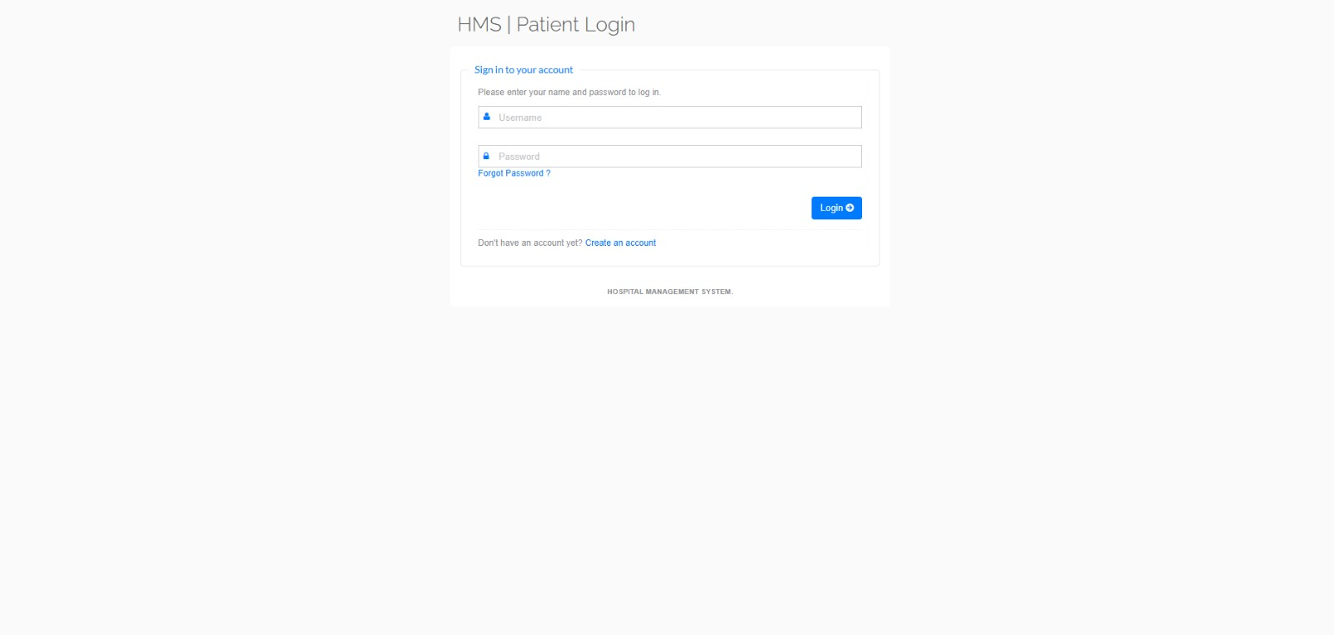

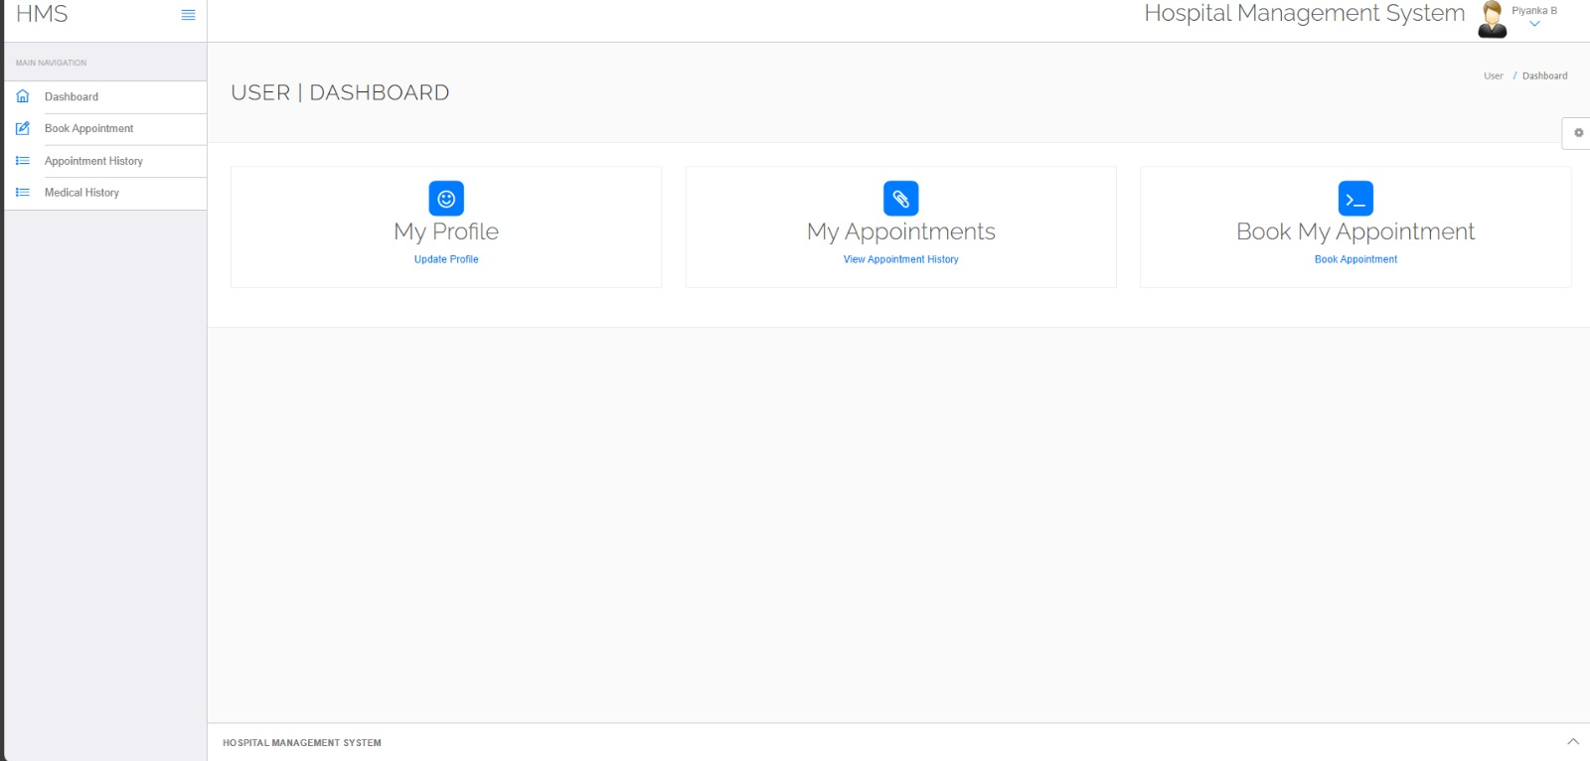

CONCLUSION:

A cardiovascular disease detection model has been developed using three ML classification modelling techniques. This project predicts people with cardiovascular disease by extracting the patient medical history that leads to a fatal heart disease from a dataset that includes patients’ medical history such as chest level, blood pressure, etc. This Heart Disease detection system assists a patient based on his/her clinical information of them been diagnosed with a previous heart disease. The algorithms used in building the given model are Logistic regression, Random Forest Classifier and KNN The accuracy of our model is 87.5%. Use of more training data ensures the higher chances of the model to accurately predict whether the given person has a heart disease or not [9]. By using these, computer aided techniques we can predict the patient fast and better and the cost can be reduced very much. There are a number of medical databases that we can work on as these Machine learning techniques are better and they can predict better than a human being which helps the patient as well as the doctors. Therefore, in conclusion this project helps us predict the patients who are diagnosed with heart diseases by cleaning the dataset and applying logistic regression and KNN to get an accuracy of an average of 87.5% on our model which is better than the previous models having an accuracy of 85%. Also, it is concluded that accuracy of KNN is highest between the three algorithms that we have used 88.52%. ‘Figure 6’ shows 44% of people that are listed in the dataset are suffering from Heart Disease

“THANK YOU”